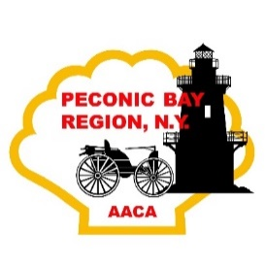 

**VENDORS ARE**

**REQUESTED TO**

**STAY UNTIL**

**2:00PM !!**

**\*\*\*\*\*\*\*\*\*\*\*\*\*\*\*\***

**Tables are limited, and are on a first come, first serve basis, and must be paid in advance!**

**CLIP HERE & RETURN!** 2022

_________________________________________________________

Your Name

_____________________________________________________

Mailing Address

_____________________________________________________

Telephone & Email

_____________________________________________________

Merchandise for Sale *(must be auto related!)*

Number of tables @ $30.00 __________

**Checks payable to**: Peconic Bay Region, AACA

**Mail to**: Bob Barauskas, P.O. Box 1615, Riverhead, NY 11901

CLIP HERE & RETURN

*Location: Southold Town Recreation Center*

*970 Peconic Lane, Peconic, NY 11958*

*Vendor Tables $30.00 each, Spectator admission $5.00 per person*

*For More Information: Bob Barauskas, Meet Chariman*

*Telephone, 631 495 8619*

*Email,* [*Bob25stude@aol.com*](mailto:Bob25stude@aol.com)

*Find us on Facebook @Peconic Bay Region AACA or at www.pbr.aaca.com*

**Peconic Bay Region – AACA**

**22nd Annual Automobile**

**Swap Meet & Flea Market**

**Sunday March 27, 2022**

**8AM – 2PM**

**Heated & Indoors!**